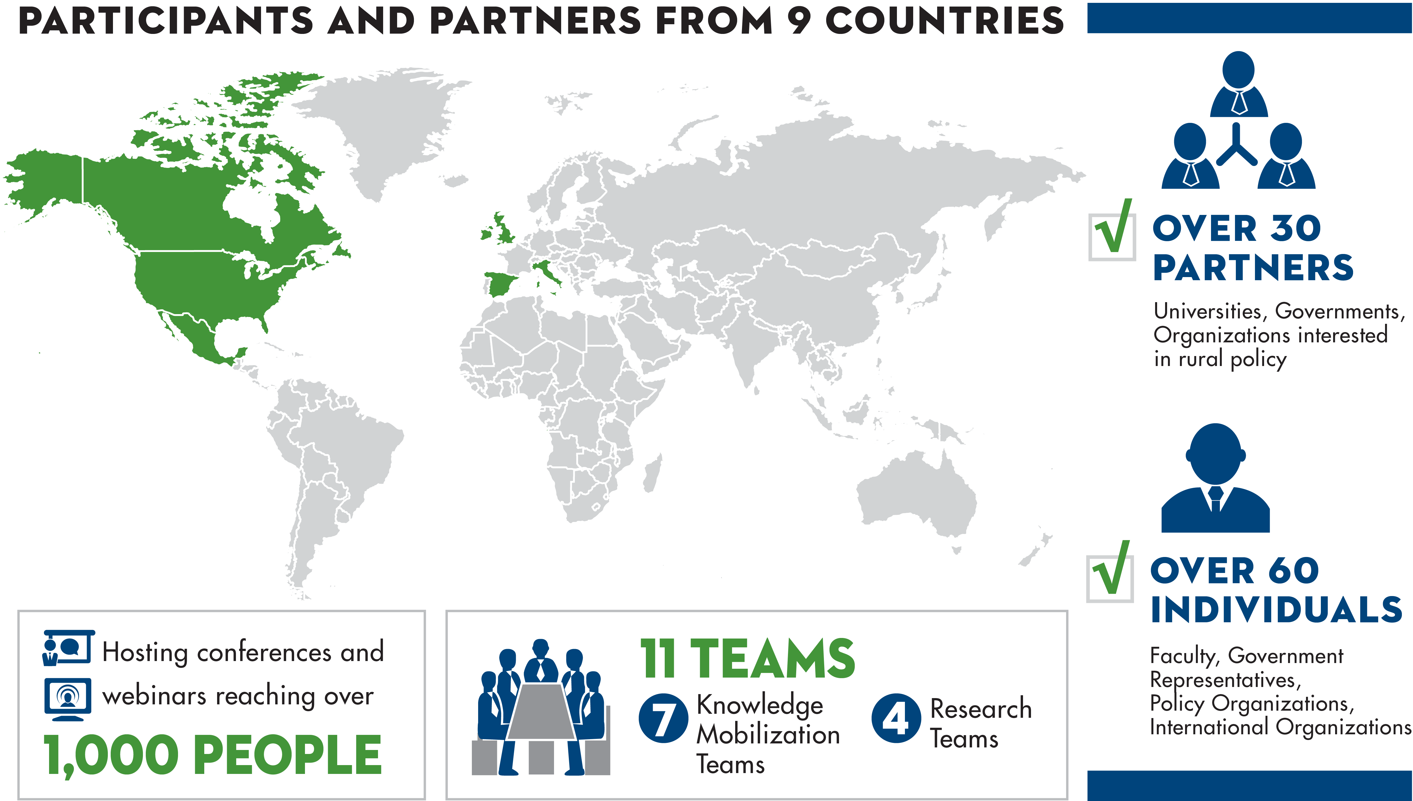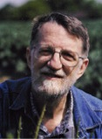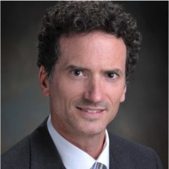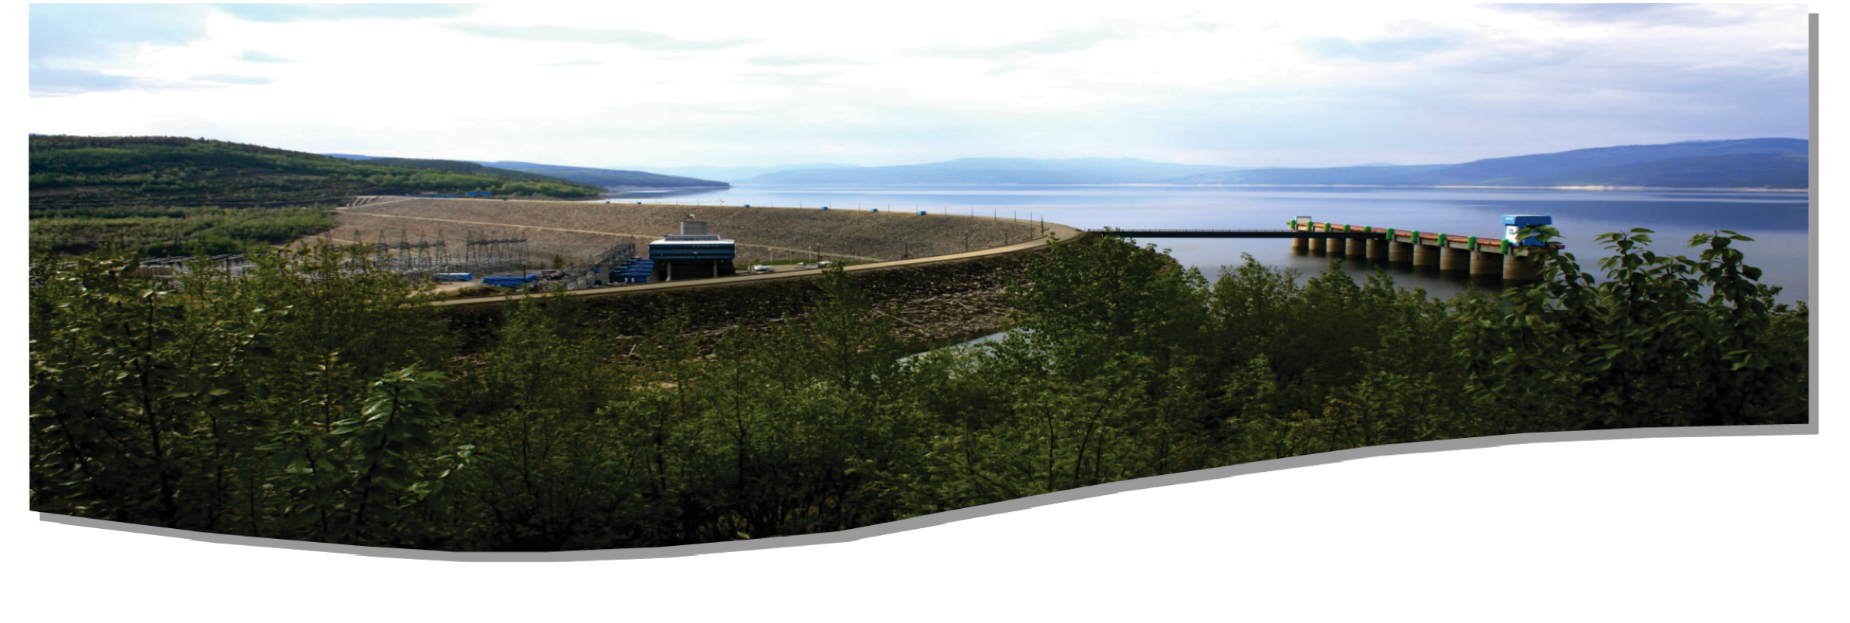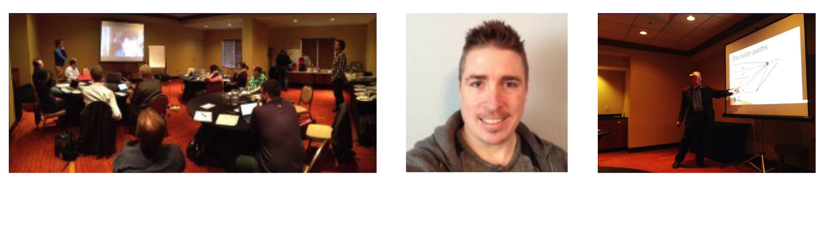

*“Brandon University is excited to lead the network amid this growing interest in comparative research and cases. We know that this shared knowledge will add considerable value to policy discussions, among faculty, students and leaders in our communities” s*tates Dr. Gervan Fearon, President of Brandon University.

*“We have established an infrastructure of and for those who are interested in the condition and fate of rural and northern people and places. Our project is about building working partnerships, connecting people and groups who have been isolated, and creating opportunities for collaboration. We hope to increase the capacity of those already busy with projects, activities, and careers that contribute to the vitality of rural and northern places.” Bill Reimer, Principle investigator, RPLC.*

Welcome to the first edition of the RPLC Newsletter! It is almost a year since we began our adventure and already we have many achievements to report.

We have established a network of 60 participants and 30 partners across 9 time zones. We have set up four Theme Teams and seven Knowledge Mobilization Activity Teams – each with active agendas and ambitious visions. We have produced and/or supported three conferences, more than 10 webinars and presentations, and the ICRPS summer school in Mexico.

**CALENDAR of EVENTS**

* **OECD Conference**  
  May 15-22, 2015   
  in Memphis
* **RUPRI Conference**  
  May 18, 2015   
  in Memphis
* **ICRPS**  
  June 22-July 6, 2015   
  in Ireland
* **CRRF Conference**  
  September 16-19, 2015  
  in P.E.I

Volume 1: Issue 1 | May 2015

*building rural policy through international comparative analysis*

*construire des politiques rurales fondées sur l’analyse comparative internationale*

The RPLC is a project that learns by doing. Our aim is to build on what is already out there, not to reinvent the wheel. Through collaboration and networking, the RPLC hopes to add to the research of rural policy as it applies to governance, infrastructure and services, human capital and migration, and natural resource development. We will apply these through institutes, research and exchanges, policy fora, distance learning activities, publications, a digital information hub, and social media.

We hope to strengthen comparative research by evaluating policy alternatives, expanding the tools available to policy-analysts and practitioners, and preparing policy-makers for a world where rural-urban interdependence is the norm.

* A SSHRC Research Grant
* A research project
* A project focused on developing countries—although it does not necessarily exclude them
* An academic project alone
* A Social Sciences and Humanities Research Council (SSHRC) Partnership Grant
* Focused on developing and strengthening partnerships amongst researchers, research institutions and rural stakeholders
* An ongoing project that is inclusive of all countries: east and west, north and south
* A project that will build the capacity of rural policy researchers, policy analysts and community stake-holders

**The RPLC is NOT…**

**The RPLC is…**

**What is the RPLC?**

**What is the RPLC?**

Volume 1: Issue 1 | May 2015

**Team Lead:** Sean Markey

Associate Dean, Faculty of Environment and

Associate Professor, Resource and Environmental Management

Some Fraser University

**Q: Infrastructure is a key issue for many rural communities. What do you believe this team can bring to the policy discussion?**

SM: We need to know how infrastructure and services are implicated in rural and northern places since they are particularly vulnerable to the long distances and low densities involved. Our team will bring to the commons, up-to-date intelligence on who is doing what on this topic and where the gaps in our knowledge lie. We will ensure that our partners do not overlook infrastructure and services issues in their own deliberations and facilitate the integration of these insights and actions in their work.

Infrastructure and Services are especially important in rural and northern places because of the distances and low densities involved. Health, education, and occupational skills of rural and northern places are in danger. Low density and long distances jeopardize access to roads, trains, planes, and high speed internet as a result of high costs and lack of availability.

The Infrastructure and Services theme team has been put in place to consider alternative policies and innovative responses to these challenges and propose activities that can pass on options to partners and the public everywhere.

**Q: What is your vision as team lead?**

SM: To become the “go to” place for information about current research and activities regarding rural and remote infrastructure and services. This includes providing advice, making connections, and facilitating the development of collaborative, comparative, and useful initiatives. Working with the other teams of the RPLC we will create reliable and stimulating resources for better rural policy and action.

**Future plans?**

We will conduct literature reviews on the state of infrastructure, translate graduate student thesis work into policy brief documents, conduct webinars and presentations, and develop the inventory of research related to infrastructure and services.

**What has the team been up to?**

We have established the team, identified key issues to consider, and developed a strategy for collecting an inventory of individuals, groups, organizations, and networks with an interest in infrastructure and services.

Team Highlight

*Each issue will highlight one of the RPLC’s Teams.*

**Infrastructure and Services**

Volume 1: Issue 1 | May 2015

**What Will We Accomplish in the Future?**

* Develop a Comparative Rural Policy Study Abroad Program
* Develop a credit-based Graduate Certificate in Comparative Rural Policy
* Increase collaboration and networking opportunities with national and international research centres, government agencies (OECD, UN), students, faculty, and policy analysts
* Develop approximately 250 publications
* Support 7 Institutes
* Develop 15-20 Rural Policy briefs—peer reviewed manuscripts
* Train more than 500 students and professionals in international rural policy issues
* Develop and inventory of people, projects, groups, and networks contributing to better rural and northern-related policy

Steering Committee Meeting,   
Toronto 2015

Wayne Kelly,   
RPLC Coordinator

Steering Committee Meeting, Toronto 2015

**In the last year, the RPLC has...**

* Hired 3 students to join the Secretariat — 2 Liaison Officers and the RPLC Coordinator
* Hosted 6 webinars on rural policy — 2 related to   
  human capital and migration, 3 related to research   
  and exchange, and 1 related to infrastructure
* Developed 4 publications — 2 on the State of Infrastructure in Canada, 2 on Governance
* Supported ICRPS 2014 in Mexico and the CRRF Conference in Thunder Bay
* Supported travel to rural development conferences   
  for students and faculty
* Developed a 12th team—The Indigenous Team
* Integrated a web-based platform for cross-national comparative research methods, professional development tools, and internship opportunities
* Completed a scan of policy programs in Canada   
  with a rural focus

**What Have We Been Up To?**

Volume 1: Issue 1 | May 2015